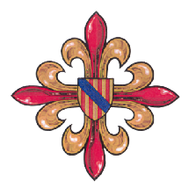

MOC

Military Order of the Collar of Saint Agatha of Paternò

Grand Priory of Terra Danubica

BOOKING FORM

I/we wish to reserve…….place/s to attend the MOC Investiture and Gala Dinner in Sofia, Bulgaria on 5th of October, 2024 at the cost of 170 Euro per head.

Name…………………………………………………………….. Rank………………………………

Title/Office held………………………………………………………………………………………

Address…………………………………………………………………………………………

Tel……………………E- mail ……………………………………………Mobile……………………

Full names of guests (for table plan)

Preferred dining table seating arrangements

Special dietary requirements: ……………………………………………………………………….

  - I/We wish to reserve ….. place/s for the informal dinner on 4th of October 2024 at the cost of 95 Euro per person, to be paid with this booking to the indicated account.

Signature………………………………………

Booking forms must be returned no later than 5th September 2024. Please send the booking form to Don Ivan Tzvetkov CollMOC, Grand Prior of Terra Danubica
Tel.: +359 889858385 e-mail: golubini51ivan@gmail.com.

The Grand Priory of Terra Danubica supports The Charitable Foundation of MOC-Bulgaria

‘Impavidus pavidum firmo’

